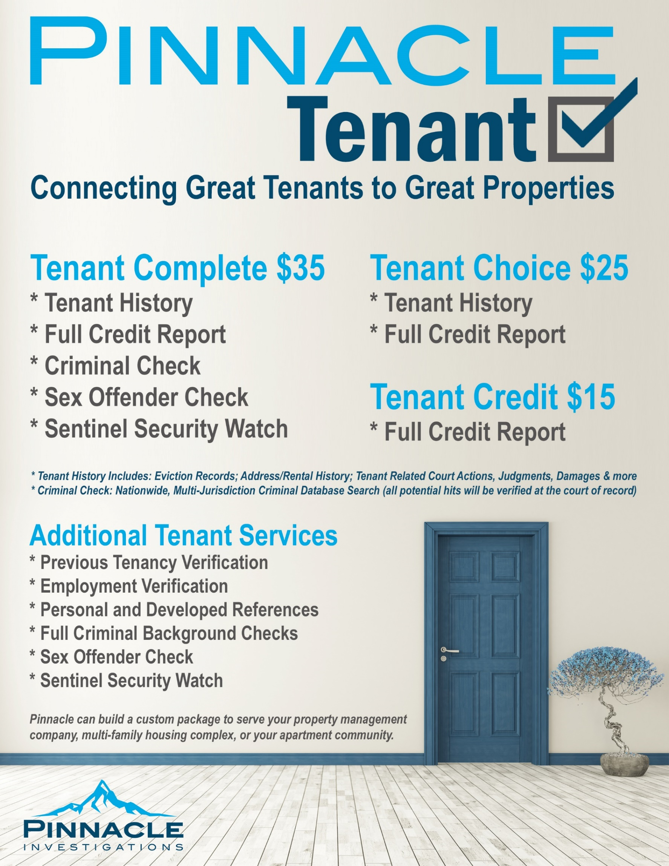
Pinnacle TenantCheck Products

Credit
- Full Credit Report provided by Transunion for Tenant Purposes

Tenant History
- Address History: All reportable address history associated with an applicant’s social security number; includes rentals, leases, ownership, and long-term places of residence even if not officially listed.
- Tenancy Search: Uses largest actionable intelligence database compilation of its kind. Searches tens of millions landlord-tenant records to deliver critical information not available through credit reports alone.
- Tenant Related Court Actions: Leverages the database’s unmatched and industry-leading courthouse research expertise and highly-sophisticated, proprietary heuristic matching engine technology and examines billions of name and address history records to develop a more complete picture of an individual's historical residential leasing behaviors, including past court actions, unlawful detainers, monetary judgments, court-ordered possession and property damage claims.

Criminal Records Check
- National Criminal Database: High-speed multi-jurisdictional search of proprietary databases compiled from multiple sources consisting of court records, incarceration records, prison/inmate records, probation/ parole/release information, arrest data, wants and warrants and other proprietary sources. New public records are captured by this search in 24 hours or less – up to 60 days faster than competing solutions. The unique searching methodologies overcome obstacles such as misspelling and punctuation, transposition and applicant fraud. All aliases are included. This is not a search of official court records; any possible records are verified at the court of record before being reported. Monthly monitoring service is available for this product.
- Sex Offender Search: A search of all names associated to the applicant in the National Sex Offender Public Registry. This search includes up-to-date information from public state, territorial and tribal sex offender registries maintained by each jurisdiction. Note: Not all convicted sex offenders are part of the public registry.
- Sentinel Security Watch: This search is designed to assist users in their compliance efforts with the USA Patriot Act and includes a multitude of databases covering U.S. and foreign sanctions and watch lists as provided by states, U.S. and foreign governments and international organizations. Complete source list is available.

